2021 Virtual Insurance Careers Month

While the 2021 Insurance Careers Month will be virtual due to the coronavirus pandemic, we look forward to global conversations that will highlight how you can bring your authentic self to work in insurance, can create your own career path and help others climb, and how companies are emphasizing wellness and mental health and are making a difference. We look forward to your stories and inspiring others together to choose insurance as a career. Thank you for your leadership in the industry and collaboration.

Key Hashtags
Please include the #insurancecareersmonth and #ICM2021 hashtags in social media posts and review the social media calendar for daily hashtags.

Weekly Themes
February 1 – February 5 Weekly Theme
“Bringing Your Authentic Self to Work in Insurance”
Showcase how employees and students can bring their authentic selves to work, how your company is advancing diversity, equity, and inclusion, how your company is celebrating Black History Month, and how employees are blending professional and personal passions with philanthropy, employee resource groups and other initiatives.

February 8 – February 12 Weekly Theme
“Creating Your Career Path in Insurance & Helping Others Climb”
Highlight career opportunities with your company, apprenticeship and internship opportunities, veteran initiatives, how your company supports career development and reduces financial barriers, and how your company helps accelerate careers.

February 15 – February 219 Weekly Theme
“Focusing on Wellness & Work During a Pandemic and Post Pandemic”
Spotlight how your company, employees, and students are focusing on wellness and mental health as we are working from home during the pandemic and during regular business operations. Highlight how your company has kept employees connected and why your employees love working for your company.

February 22 – February 26 Weekly Theme
“Finding Purpose, Philanthropy, & Innovation in Insurance”
Showcase how your company is purpose driven and gives back. Highlight emerging leaders in your company and how they are driving the industry forward. Spotlight innovation in your company and the industry and the important role insurance plays with consumers and in the economy.

Social Media Challenges & Focus Areas
Throughout the month of February, you are encouraged to post talent content across your social media platforms. In addition, following are social media challenges and engagement activities.

February 1 – February 5: Authentic Careers in Insurance YouTube Challenge
February 8 – February 12: LinkedIn Article Post Challenge
February 10: Virtual Coffee Networking Day
February 15 – February 19: Go Live From Home Week
February 22 – 26: Selfies & Throw Back Pictures Week
February 22 – 23: Virtual Emerging Leaders Conference and Rising Stars Recognition

YouTube Challenge
“Authentic Careers in Insurance”

When: Post your video on YouTube between February 1 and February 5.
Title: Include “Authentic Careers in Insurance” in the title of your video.
Content: Showcase how employees and students are bringing their authentic selves to work and the career opportunities in insurance.
Length: 1 – 10 minutes
Tags: Include “Insurance Careers Month” as one of the tags for your video.

LinkedIn Article Post Challenge

When: Post your LinkedIn article between February 8 and February 12.
Content: Write article posts on LinkedIn that highlight career path opportunities in your company including apprenticeships, internships, scholarships, veteran initiatives, and career development opportunities.
Hashtags: #insurancecareersmonth #ICM2021

Virtual Coffee Networking Day

When: Host a virtual coffee networking event on February 10.
Content: Host a virtual coffee networking event to help people connect with others, learn more about career opportunities in the industry, and meet potential sponsors, allies, and mentors. Connect with students and people at all stages of the career pipeline.
Hashtags: #ICM2021 #insurancecareersmonth #insurancenetworking

Go Live From Home Week

When: Go live on the social media platform of your choice between February 15 and February 19.
Content: Go live on Instagram, Facebook, YouTube, LinkedIn or another social media platform of your choice and discuss career opportunities in insurance. Share how your company is also focusing on wellness, staying connected, and advancing diversity and inclusion while we stay home during the pandemic.
Hashtags: #InsuranceCareersMonth #ICM2021 #insurancecareers #insuranceishiring
LI Live Chat: Join the Insurance Careers Movement and The Jacobson Group on Tuesday, February 16 as we go live on LinkedIn to talk about career opportunities in insurance and how the industry is adapting during this time.

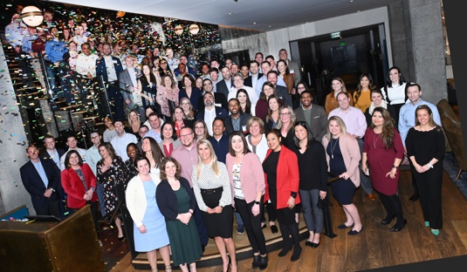
Selfies and Throw Back Pictures Week

When: Post selfies and throw back pictures between February 22 and February 26.
Content: Post selfies and throw back pictures from working in insurance. Share current pictures while we work during a pandemic and throw back pictures that highlight company culture, industry events, insurance giving back, and how the industry helps during times of need. This picture is from the 2020 Emerging Leaders Conference and features the 2021 class of Emerging Leaders.
Hashtags: #InsuranceCareersMonth #ICM2021 #insurancecareers #insuranceishiring

Virtual Emerging Leaders Conference and Rising Stars Recognition

When: Post pictures of emerging leaders and rising stars in insurance on February 22 and February 23.
Content: The Virtual Emerging Leaders Conference will be held February 22 and 23. Post pictures of your selected Emerging Leaders and your rising stars in insurance. Highlight how they are making a difference in the industry through their work on the coronavirus pandemic, diversity, equity, and inclusion, and innovation in insurance. This picture is from the 2020 Emerging Leaders Conference.
Hashtags: #ELC2021 #ICM2021 #insuranceemergingleaders #insurancerisingstars

